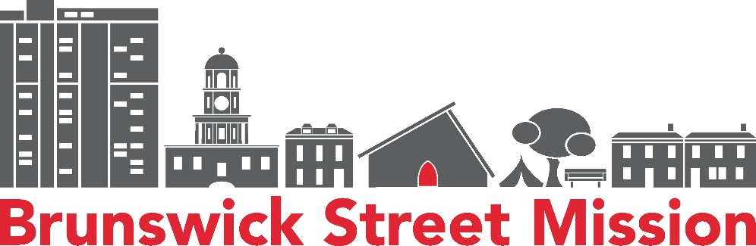

JOB DESCRIPTION – Kitchen Assistant
This is a placement via the Canada Summer Jobs (CSJ) program. The job will run for 9 weeks, from the beginning of June to the end of July. Participants must be between 19 and 30 years old on the first day of employment. We will be paying $17.50/hr, 30 hours a week. On the job training will be provided where needed. Hours will be generally Monday to Friday, 6am to 12pm initially, but flexible hours can be discussed. The Kitchen Assistant will report to the Kitchen Coordinator.
Tasks and Responsibilities, may include but are not limited to:

Breakfast Service
- Ensure adequate food stores to prepare breakfast Monday to Friday, with a varying menu Shop for foods (online or in person) to ensure we have enough food for breakfast
- Incorporate Feed NS deliveries into breakfast planning and delivery
- Conduct and oversee breakfast activities including cooking, setting up dining room, and serving breakfast guests
- Oversee dining room activity
- Manage volunteer activity and enforce safe food handling

Take Away Food Service
- Plan and prepare nutritious frozen meals every week for the food bank
- Ensure ingredients and allergens are tracked and labelled
- Plan to use up food items that the food bank cannot use due to excessive amounts or undesirability
- Shop for necessary ingredients to augment recipes created above
- Lead volunteers in food prep and packaging

Other
- Lead by example in demonstrating a positive attitude and actions through a display of courtesy, service, cooperation, hospitality, sensitivity, and professionalism
- Train, support, and provide leadership to volunteers

Team Work & Organizational Support
- Be committed to the Brunswick Street Mission’s mission, vision, values and purpose of Brunswick Street Mission
- Collaborate with other team members to foster the success of our organization as a whole
- Greet clients and provide a prompt, courteous and welcoming experience.
- Assist when required/as possible with other areas of the organization
- Actively participate in events designed to enhance employee relations

Education/Experience/Qualifications
- Minimum 1 year food preparation experience
- Training in Safe Food Handling or willingness to be trained immediately
- Experience working with folks from a variety of backgrounds
- Demonstrated experienced with crisis intervention
- Technology functional aptitude with MSOffice
- Understanding and commitment to harm reduction
- Criminal Record Check
- Preferred: access to a reliable vehicle for offsite duties (mileage is paid)
- Preferred: Basic First Aid & Naloxone training

This is a hands-on role that requires physical fitness, with use of stairs and lifting required.
We welcome and encourage applications from the Indigenous community, people with disabilities, racially visible community, women, queer community, and folks who contribute to the diversity of our community.
Please submit your resume and cover letter to codi@brunswickstreetmission.org. Deadline to apply is Monday May 7th at 11:59pm.

