**Letter to Financial Institutions**

(INSERT MONTH/DATE), 2025

To Whom It May Concern:

The bargaining unit members of the Dalhousie Faculty Association were engaged in negotiations towards a new union contract with Dalhousie University.

These negotiations began on May 26, 2025. We had hoped a satisfactory collective agreement would be reached, however, there is an impasse resulting in Dalhousie University declaring a lock-out effective August 20, 2025. Many of our members on the picket lines will be without their regular employment earnings during the work stoppage.

We have many members who have loans with your institution. We are advising them that if their personal circumstances require, they should seek to reach an accommodation directly with your branch managers for a temporary deferral of payments on loans.

It is my hope that your institution will honour our members’ patronage with your co-opera­tion, so that individuals and their families will not face undue hardship.

If you require further information or clarification about the situation, please contact me at [numerm@gmail.com](mailto:numerm@gmail.com).

Yours sincerely,

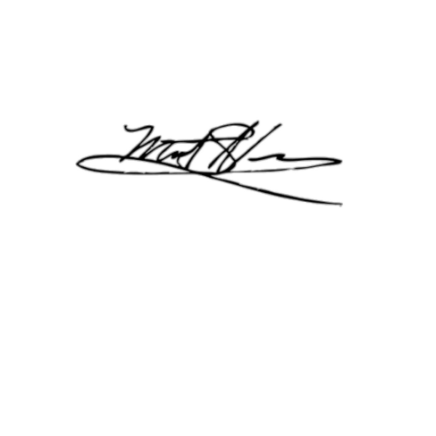

Matthew Numer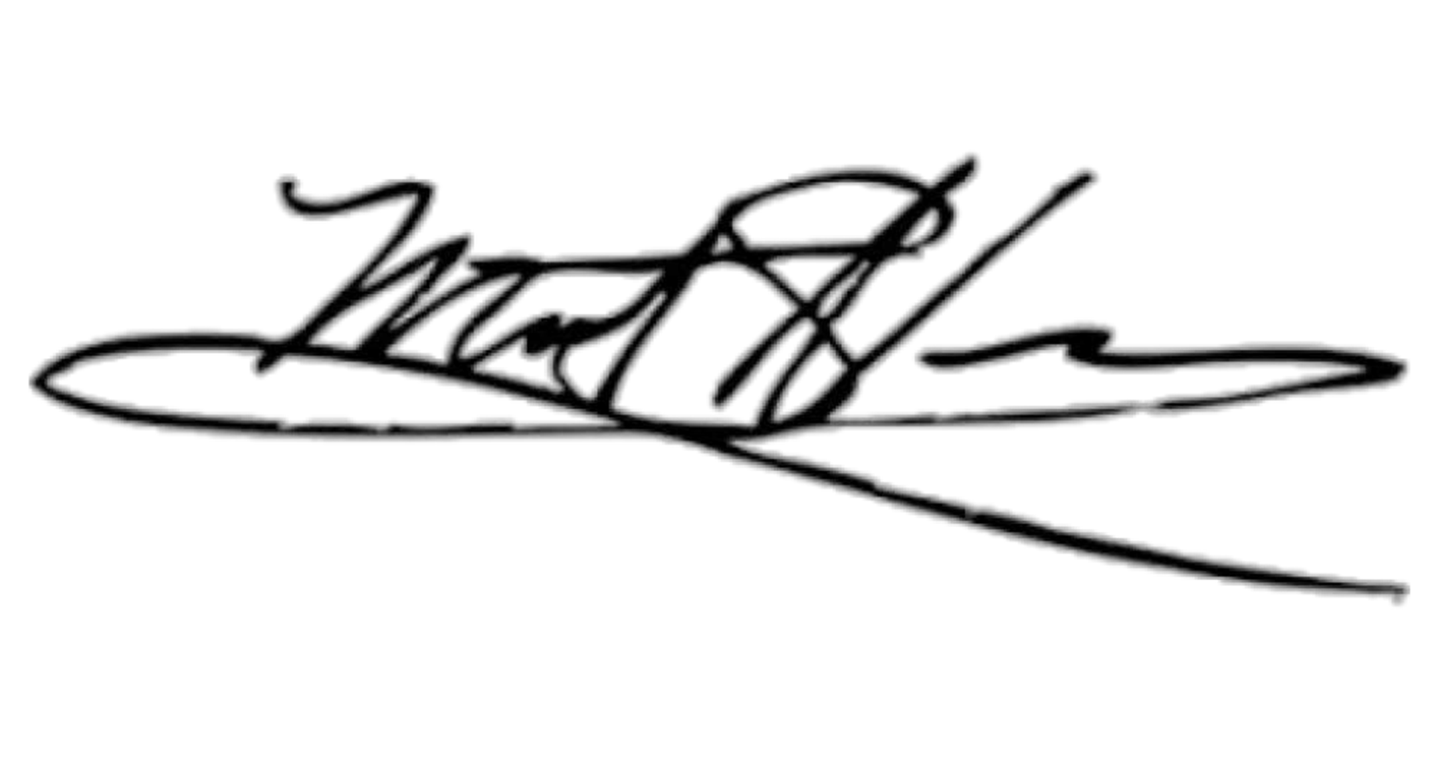

Chair, Finance Committee

Dalhousie Faculty Association