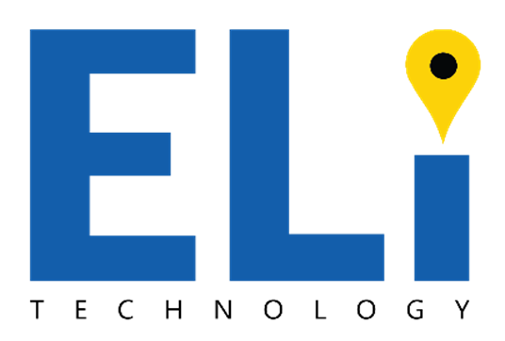

Corporate Presentation – Confidential​

2020



**112 Operator Design Thinking Workshop Whitepaper**

Table of Contents

1. DISCLAIMER 3

2. FOREWORD & MESSAGE FROM ELi CEO 4

3. BACKGROUND 5

4. OBJECTIVE 6

5. WORKSHOP OVERVIEW 6

5.1 Design Thinking Approach 6

5.2 Understand Phase 6

5.3 Explore Phase 7

6. UNDERSTAND PHASE 8

6.1 User and Stakeholder Map 8

6.2 Persona Map 8

6.3 Persona Map – Call Taker 9

6.4 Persona Map – Caller 10

6.5 As Is Scenario 11

6.6 Needs Statements 11

6.7 Needs Statements – Call Taker 11

6.8 Needs Statements – Caller 12

7. EXPLORE PHASE 13

7.1 EML Idea Overview 13

7.2 To Be Scenario 13

7.3 To Be Scenario – Call Taker 13

7.4 To Be Scenario – Caller 14

7.5 Roadmap 14

8. CONCLUSION 15

# DISCLAIMER

This document is written for the specific purpose of being an education/ information tool surrounding the product known as Emergency Mobile Location or EML.

Its contents are the property of ELi Technology, Halifax, Nova Scotia. Any distribution therefore must be done so with the express permission of the author.

**General disclaimer information**

This manual contains information, data, linked documents, pages and images prepared by ELi Technology ("the Information"). The Information is protected by the Copyright Act of Canada.

Whilst the Information contained here has been presented with all due care and diligence, ELi Technology warrants or represents that the Information is free from errors or omission.

The Information is made available on the understanding that ELi Technology shall have no liability (including liability by reason of negligence) to the users for any loss, damage, cost or expense incurred or arising by reason of any person using or relying on the information and whether caused by reason of any error, negligent act, omission or misrepresentation in the Information or otherwise.

**Accuracy of information**

Whilst the Information contained within this document is considered to be true and correct at the date of publication, changes in circumstances after the time of publication may impact on the accuracy of the Information. The Information may change without notice and ELi Technology is not in any way liable for the accuracy of any information printed and stored or in any way interpreted and used by a user.

# FOREWORD & MESSAGE FROM ELi CEO

**PETER WOODFORD**

I have been immersed in the emergency number industry for over 12 years with a background in telecommunications, financial networks, digital communications. Over that time, there has lingered a huge concern over mobile location information surrounding the ESN (the Emergency Service Networks). It’s a global problem, resulting in thousands of lives being lost every year because callers are not being located quickly enough.

There are some fundamentals to life every human has the right to…and a good standard of public safety is one of them. National Public Safety services starts with Emergency Call Takers and First Responders. They are the front line; the men and women who go above and beyond, risking their own lives and facing daily challenges to help save the lives of others. Yet, for the many emergency calls received each day, there remains a large group of emergency callers who dispatchers simply cannot locate effectively. When time is wasted trying to find the location of an emergency, dispatch and response times increase and lives are lost. Our EML methodology can change all that, creating a better future for the Emergency Service Number Industry and most importantly, saving lives, providing emergency telecommunicators and first responders with the tools they need

Our EML methodology is revolutionary; it is the only methodology available that can provide the dispatchable address, indoor localization and GPS coordinates (Z axis also available) anywhere in the world. Collectively we cannot save one life unless we are prepared, informed and undertake the responsibility of leadership. The time to improve our emergency service industry is now!



Peter Woodford, CEO

# BACKGROUND

It’s a question that is asked in the US 240,000,000 times each year (according to NENA):

“**Where is your emergency?”**

Accurate emergency mobile location information is the Public Safety Industry’s biggest challenge. Tens of thousands of lives worldwide are lost each year because Emergency Responders cannot locate the caller in time. Current emergency calling location services are unable to provide a verifiable, dispatchable location for mobile callers, and this impedes the efficiency and effectiveness of the Emergency Service.

**Watch our video on the Industry dilemma** [**here**](https://www.nbcnews.com/nightly-news/video/911-can-t-always-get-accurate-locations-from-cell-phones-1135073347526)**.**

ELi Technology is dedicated to resolving ongoing concerns surrounding inaccurate location information.

We patented and developed “Emergency Mobile Location” (EML), the world’s first and only location methodology that provides 2 pieces of localization information; GPS and dispatchable address, including indoor location information. It is technologically neutral and GDPR/PPII privacy compliant.

EML utilizes existing Wi-Fi access point infrastructure and can be adapted for a variety of emergency number architectures.

EML provides:

* Accurate, **real-time**, **indoor**, **rural** and **urban** location information
* A verified, dispatchable civic address, including floor and apartment number
* GPS, latitude and longitude
* Depending upon handset capability, a vertical reference represented as altitude is available.

# OBJECTIVE

In February 2020, ELi Technology, with support from our partners at IBM, facilitated a Design Thinking and Technical Workshop with one of the leading 112 Operators in Europe.

The workshop was designed to get a better understanding of the 112 Operator’s operations needs and desired future states. Their openness and participation during the workshop led us to a consensus in the value accurate dispatchable localization information brings to 112 call handling and operations. Achieved outcomes would include call handling time reductions, efficient utilization of resources, stress reduction for callers and call takers, which in the end would lead to saving more lives.

This document provides a summary of the workshop, the outcomes and our vision going forward.

# WORKSHOP OVERVIEW

## Design Thinking Approach

Design Thinking is an iterative process in which we seek to understand the customer, challenge assumptions, and redefine problems in an attempt to identify alternative strategies and solutions that might not be instantly apparent with our initial level of understanding.

## Understand Phase

The workshop began with the Understand Phase where we sat with 112 operations professionals to understand their point of view, their pain points and the day by day challenges they face.

This included:

* Developing a user and stakeholder map.
* As is Scenario Mapping
* Needs Statements

## Explore Phase

During the explore stage of the workshop, the team members began to "think outside the box" to identify new solutions to the needs statement created, and began to look for alternative ways of viewing the problem.

This included:

* Presenting the EML Idea Overview
* Developing the “To Be” scenario
* Developing a road map
* Mapping the stakeholder flow of information

# UNDERSTAND PHASE

## User and Stakeholder Map

The user and stakeholder map activity is used to capture the full landscape of stakeholders that are relevant for a successful project.

The following Stakeholder Map was created during this exercise:

After creating the map, a few user and stakeholder clusters were identified. The discussion led to a decision of two clusters that were the most important and the highest prioritized to continue working on as personas throughout the workshop. The two decided clusters were:

* Call taker
* Caller – 112

## Persona Map

The persona map activity is used to gain a better and shared understanding of the chosen persona by exploring it in four different dimensions; role/does, feels, pains and gains.

## Persona Map – Call Taker

The created persona map of the call taker identified several pains from their current experience, which are opportunities for the 112 operator and ELi to turn into future gains for the persona. Some of the identified pains and gains were:

* Pains
  + When callers do not know where they are
  + Callers think that the 112 operator knows where they are
  + When location information is not accurate enough
* Gains
  + Quick and correct location
  + Faster help and service delivered
  + Successful outcomes

The following Call Taker Persona Map was created during this exercise:

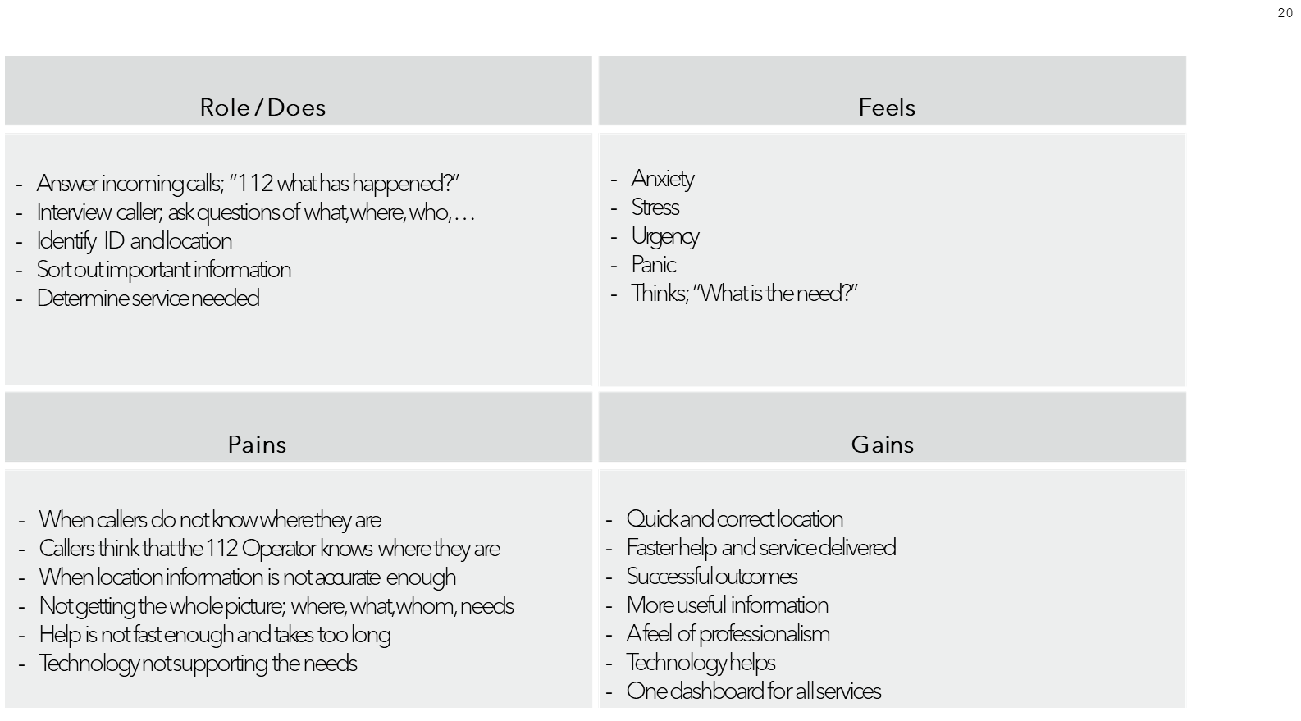

## Persona Map – Caller

The created persona map of the caller identified several pains from their current experience, which are opportunities for the 112 operator and ELi to turn into future gains for the persona. Some of the identified pains and gains were:

* **Pains**
  + Does not know where she is
  + Unaware of location
  + Does not speak Swedish
* **Gains**
  + Receives faster help
  + Can locate first aid, fire extinguisher, defibrillator, etc.
  + Feels secure and safe

The following Call Taker Persona Map was created during this exercise:

## As Is Scenario

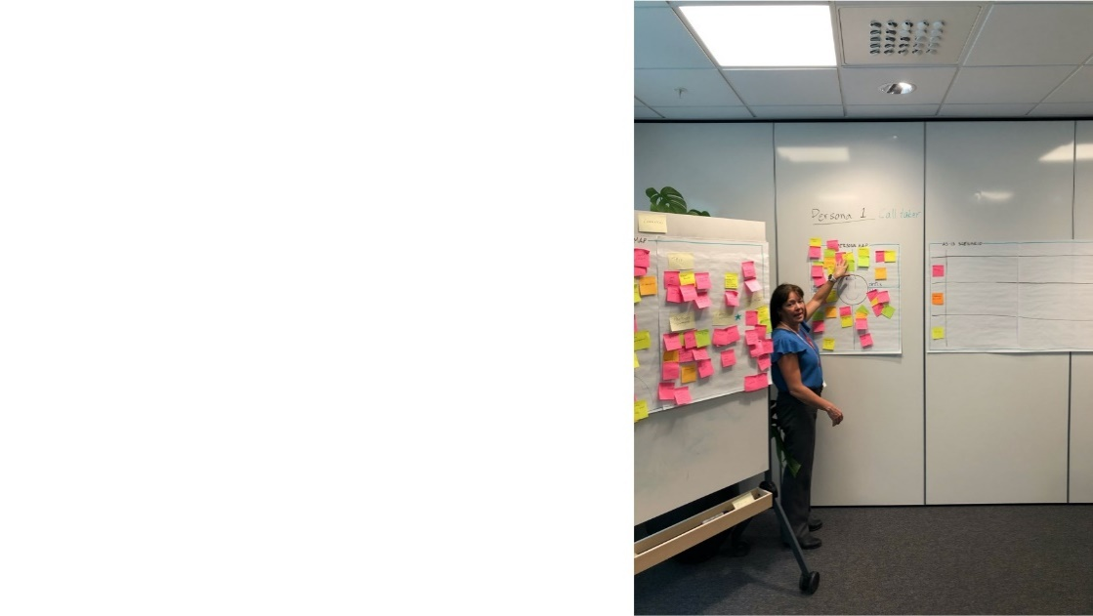The as-is scenario activity is used to map out the persona’s current experience and to identify where in the process to find the challenges and pain points that can be turned into opportunities. The group focused on the scenario from the time that someone does a call for help until the required service is delivered including the following steps:

* Answers incoming call and get first location information
* Verifies location and gets other information
* Dispatches to necessary parties
* Closes call

## Needs Statements

The need statements activity is used to frame the persona’s actual needs, desire and goal. It helps the team to establish who the user is, identify what the user needs and how the user would benefit if the need was addressed. The result from the activity was five need statements for the call taker and four needs statements for the caller. These need statements were based on the previously identified pain points.

## Needs Statements – Call Taker

* 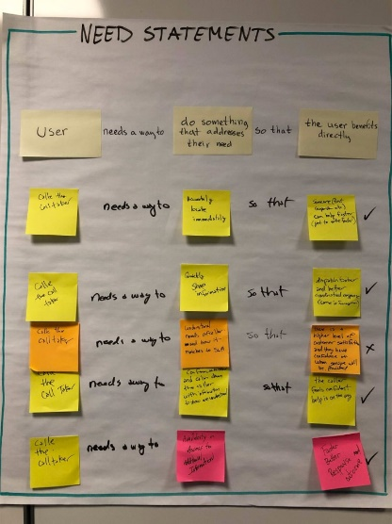The Call Taker needs a way to accurately locate immediately so that someone (e.g. first responder) can help faster
* The Call Taker needs a way to quickly share information so that the call can be dispatched faster and better
* The Call Taker needs a way to understand needs of the caller and how it matches to SLA so that there is a higher level of customer satisfaction and that they feel confident of when service will be provided
* The Call Taker needs a way to confirm, understand and calm down the caller with information showing he understands so that the caller feels confident that help is on the way
* The Call Taker needs a way to get access to additional information so that there will be a faster and better response and outcome .

## Text, letter Description automatically generatedNeeds Statements – Caller

* The Caller needs a way to collect information so that the call taker can identify her needs and give her faster and better help
* The Caller needs a way to share her exact location so that help is sent to the right place
* The Caller needs a way to be understood so that she can provide information
* The Caller needs a way to understand so that she can do the right thing, follow instructions and have the right expectations

# EXPLORE PHASE

## EML Idea Overview

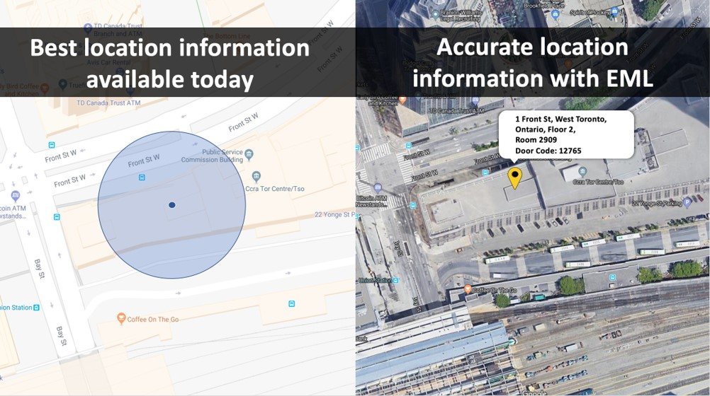The EML idea overview activity is used to gain insight to the overall capabilities of the EML methodology and to discover how it can meet the identified user pain points. This is when the problem solving starts on how to create a better future experience for the users based on EML.

The overview explained the best available location information that is used within the industry today. It gives a GPS location with a radius that represents the estimated location of the caller.

The EML methodology enables to get more accurate location information of the caller that can include address, floor, room and additional information such as door code.

ELi Technology’s Emergency Mobile Location (EML) is a methodology that leverages the capabilities of mobile phones to deliver consumer level handset location and detailed dispatchable address information for emergency calls using the Wi-Fi ecosystem to determine location.

## Graphical user interface Description automatically generatedTo Be Scenario

The to-be scenario activity is used to map out the personas’ future experience when the idea/solution is implemented. The activity identifies what necessary enablers there are and what values the future experience would bring.

## To Be Scenario – Call Taker

The result from the activity are values to the Call Taker that can be enabled by ELi’s technology in the scenario from answering incoming call to closing call. The as-is scenario will be the same, but the Call Taker will get more detailed location information faster. The identified values are:

* Can assess multiple similar calls because some info are already known
* Assist in triage calls
* Reduce stress level
* Shorter time to dispatch: consensus was minimum 30 second savings, potetnially as much as 90 seconds savings oer call.
* Reduce interruptions during interview
* Manage dispatch personnel better
* Increase confidence
* Shorter time to complete interview
* Additional information such as location of heart starter etc.
* First responder notification to caller
* Financial savings as a result of time savings; business case

## To Be Scenario – Caller

The result from the activity are values to the Caller that can be enabled by new technology, including ELi’s technology, in the scenario from an accident to getting help. Some of the identified values are:

* A correct location gives shorter wait time
* Lower stress and frustration
* Shorter time for questions and answers
* Faster and correct help
* Continual updated info

## Roadmap

The roadmap activity is used to articulate the vision for the future and deliver an experience today that sets the project down the right path. It determines the “must have” features there are in the short-term, the “nice to have” features in the mid-term and the “might need to have” features in the long-term in order to fulfill the persona’s identified needs and create value in each step.

The following “must have “ features identified can be deilvered now with the implementation of the EML solution:

* Accurate dispatchable location
* Know the location of user with respect of privacy (GDPR, protected identity)

# CONCLUSION

The workshop really broke down the value accurate localization means for multiple steps in the delivery chain of a 112 call: from the caller through to the First Responder unit. The collective consensus in the value accurate dispatchable localization information brings to 112 call handling and operations was crystalized through this exercise. Achieved outcomes would include call handling time reductions (30-90 seconds per call), efficient utilization of resources, stress reduction for callers and call takers, which in the end would lead to saving more lives and a dramatically more efficient ESN system.

EML has the “must have” features that 112 Operators need today – the immediate delivery of an accurate location when a caller has contacted 112 from their mobile phone, including indoor and multistory location, and in respect of privacy ( GDPR, protected identity).From this platform future states can be enabled; with automatic dispatchable localization EML provides, incoming calls (and other data) in the future can be more usable and manageable to create better 112 caller outcomes.



Sales inquiries

[Info@eli-technology.com](mailto:Info@eli-technology.com)

ELi Technology AB  
Helio, Time Building, Kistagången 12  
Kista, Stockholm

General contact  
  
Emily Valiant,   
Communications Director

[emily.valiant@eli-technology.com](mailto:emily.valiant@eli-technology.com)

ELi Technology Inc.  
380 Bedford Highway

Halifax, NS B3M 2L4

Technical contact  
  
Ryan Donovan,   
Technical Lead Consultant

[ryan.donovan@eli-technology.com](mailto:ryan.donovan@eli-technology.com)

ELi Technology Inc.  
380 Bedford Highway

Halifax, NS B3M 2L4

Eli Technology​

Corporate Presentation – Confidential​

January 2020