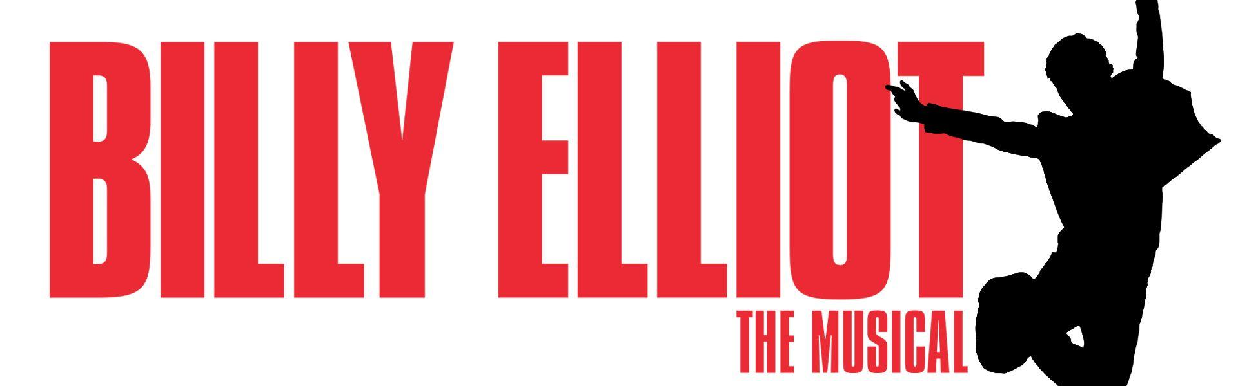
Scroll to bottom for Image Description

Audio Described Performances
We are pleased to welcome you to our Audio Described Performance of Billy Elliot the Musical here at Neptune Theatre this season! A big thanks to the Craig Foundation for their continued support in making our space more inclusive. We look forward to continuing to make this a regular part of our programming, and invite all patrons to come, be themselves and experience live theatre!

Schedule
Show: Billy Elliot the Musical
Date: May 28, 2023 at 2:00pm
Devices: Please indicate if you will be requiring a listening device when you arrive
Timing breakdown:
- 1:00pm, The theatre lobby is open to audience members. Please arrive between 1:00pm and 1:10pm.
- 1:10pm, Touch Tour. This will be a chance to get familiar with some of our props and materials on the stage. This will take place in the lower lobby with Director of Education Laura Caswell. (We know that ideally we could go onto the stage, but this production has a huge preset and fight calls before the show, which means we cannot get into the audience too much ahead of time).
- 1:25pm, Audience members using listening devices are invited into the theatre for the audio introduction. Please arrive early so that we can get you seated, distribute your radio device and then our audio describer Kat Germain will give a pre-show audio description describing the set, costumes and other elements of the production.
- 1:45pm - 2:00pm, This is a break before the show begins. You can use this time to visit the washrooms which are located in the main entrance lobby and the lower lobby, or you can get a drink at the bar. Please note, drinks are indeed allowed in the theatre.
- 2:00pm - 5:00pm, Showtime. Act 1 runs approximately one hour and twenty minutes. There is a twenty minute intermission, and then Act 2 runs approximately one hour and twenty minutes.

This performance will take place on the Fountain Hall Stage.

For introductions from the actors in the show, please CLICK HERE.

For more information about Audio Described performances, visit neptunetheatre.com/audio, or CLICK HERE

Image Description:
Rectangular banner with a plain white background. On the right is a black silhouette of a young boy jumping. His arms are over his head, and his legs are tucked up underneath him. The words, “BILLY ELLIOT” appear to take up the majority of the banner in large, bold red font. Below this is smaller red font that reads, “THE MUSICAL”.

