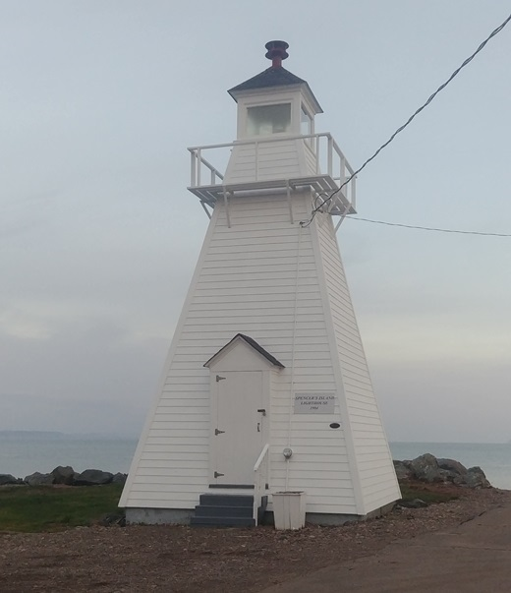 | 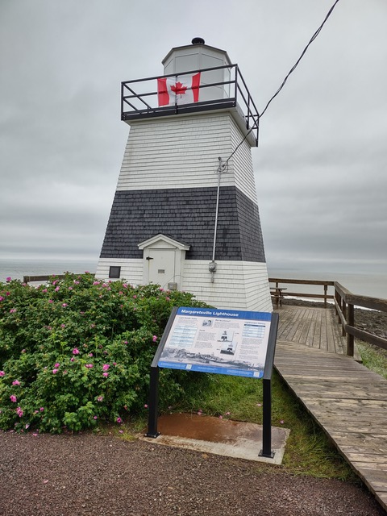
Spencer’s Island Lighthouse  Credit: Matthew Burke | Margaretsville Lighthouse  Credit: NSLPS - DPC

Coming to view the highest tides in the world? Include visits to the six lighthouses located on the Bay of Fundy coastline that open to the public and you will have a holiday to remember! Start in Hampton NS where the original lighthouse from 1911 still stands and its 6thorder Fresnel lens continues to shine at night. You can climb to the top to get a panoramic view of the area.
Down the road, Margaretsville Lighthouse built in 1859 is open to visitors who can climb to the second floor to see where the lightkeeper slept over during stormy periods to make sure the lighthouse stayed lit. Its black and white horizontal stripes made it unique among NS lighthouses.
Cross over at Windsor to the Noel Shore where the Walton Harbour Lighthouse awaits you. Recently relocated from the crumbling sandstone cliff, it is accessible to all on the ground floor with the choice to climb the stairs to the top. Ask and you may be able to wind up the clock-work gear that produced the flashing light seen in its working day!
A short drive down the road you can visit the replica of the 2nd Burntcoat Head Lighthouse. Located in a park you can take a break from the road and walk the trails, examine the ocean floor when safe to do so or watch the Fundy tides roll in and out.
Go round the end of the Minas Basin past Parrsboro and you can walk into the Port Greville Lighthouse next to the Age of Sail Museum. Lit in 1908 it shone until 1976 when the Groundhog Day storm washed all of Port Greville’s wharves and shipbuilding sheds out into the Basin. It was then shipped in two halves to the Canadian Coast Guard College in 1981 before its two halves were returned home in 2001 and reassembled into one lighthouse.
Twenty minutes down the road is the Spencer’s Island Lighthouse that had to be the one of the first lighthouses in NS acquired by a non-profit charity in 1989, two years after it was deactivated. Not content with keeping it in good shape, the Spencer’s Island Community Association got it reactivated as an aid to navigation in 2007.
For more details, visit LIGHTHOUSES Open Hours 2026
Past Posts on: Margaretville https://bit.ly/4fvkA8k
Spencer’s Harbour https://bit.ly/4phLFzg
Walton Harbour https://bit.ly/4h8dbwV

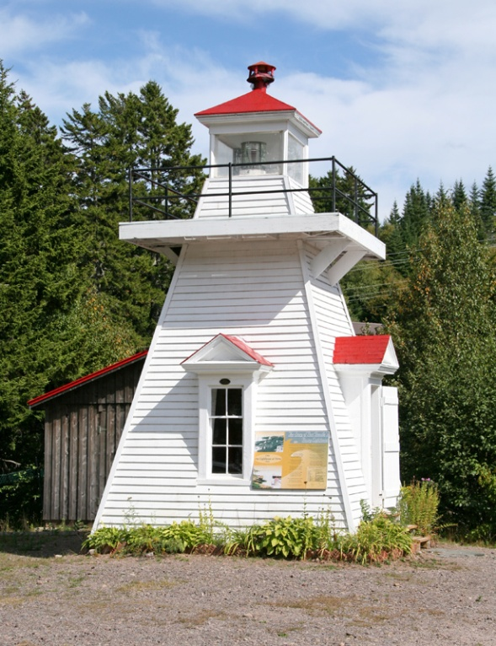 | 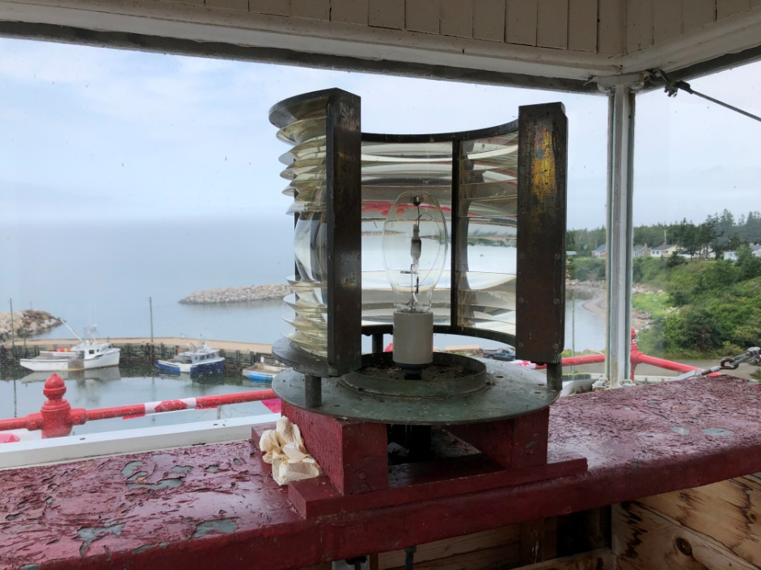
Port Greville Lighthouse  Credit: Lighthouse Friends | Hampton Lighthouse Fresnel Lens  Credit: NSLPS - DPC

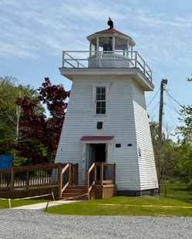 | 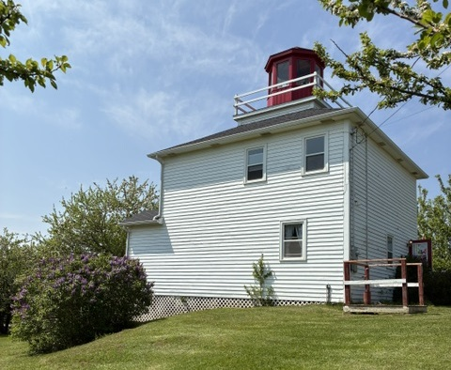
Walton Harbour Lighthouse  Credit: NSLPS - DPC | Burntcoat Head Lighthouse Replica  Credit: NSLPS - DPC

