
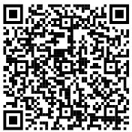
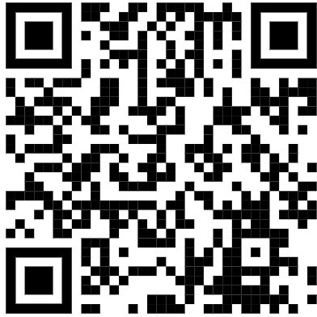

NSTU Leaves Overview
ALWAYS REFER TO THE ARTICLE LISTED IN THE AGREEMENT FOR FURTHER DETAILS. This is not a complete list. ALWAYS check your agreements. Review professional development funding (article 60: for leaves including educational leaves, conferences etc.)
REGIONAL AGREEMENT (Until July 31, 2027)

ARTICLE 3 SICK LEAVE
3.01 (a) Teachers shall be entitled to twenty (20) days sick leave with full pay, during each year. Accumulate up to 195 days. (Easy Connect Code: 200)
(b) Can be for medical, optical and/or dental treatment that cannot be made outside of school hours

ARTICLE 4 BEREAVEMENT/SPECIAL LEAVES

Death in immediate family (Code: 630)
Up to 5 days with pay for each death
The RCE may grant up to 2 additional days for travel
1 of the total leave days may be taken for the internment or memorial service if scheduled after original leave

Funeral of Aunt, Uncle, Niece, Nephew
1 day with pay if service falls on a teaching day
The RCE may grant up to 2 additional days for travel
  - Article 4.01 & 4.02 apply to substitute teachers who have been classified as a “regular teacher” (TPA Article 32)

Death of staff or student of school
Teachers may be permitted to attend the funeral service in consultation with Human Resources Staff
Special Leaves

Serious family illness: Up to max 10 days with pay for serious illness in the teacher’s (or their spouse’s) immediate family (see definition in contract). The RCE may grant 2 additional days for travel (Code: 614)

NSTU Family illness: Upon approval from principal/supervisor (or designate), can be for appointments Up to max of 3 days each year from the 10 in 4.05 (Code 615)

Urgent & Imperative Responsibilities (*fire, flood, deployment of spouse, etc.-see contract for full detail) Up to 3 days with pay Responsibilities outlined in 4.07

Major Holy Days: Upon application, up to 3 days with pay
For practicing adherents of established Religious Faiths to participate in major Holy Days of their religion. (Code:648)

Living Donor: Up to 10 days with pay to be a living donor.
This leave allows time required for testing, counseling, consultation, extraction and recovery.
TEACHERS PROVINCIAL AGREEMENT (Aug.31 2026)⁾

PAID LEAVE
  - Injury on Duty *see contract, 14 days to report, up to 2 years
31.12 Discretion Day: 1 day leave with pay (Subject to operational requirements) (Easy Connect Code: 151)
32.07 When a substitute teacher becomes classified as a regular teacher, as provided in 32.03 and 32.04, the substitute teacher shall be entitled to sick leave of 1 day for each ten (10) days taught

UNPAID LEAVE
28.01 Compassionate Care Leave Unpaid leave, minimum 2-week blocks Insurance benefits remain I effect (Code:180)

31.05 (i) Represent NS in Sports Competition
While actively participating in a National, British Commonwealth, or international sports competition to represent Nova Scotia (Code: 660)
- National / International Arts / Cultural Event To attend while actively participating in national or international arts / culture event. (Code: 662)

NO LOSS IN SALARY FOR THE FOLLOWING
29.01 Birth of a Child (non-birth parent)
- days with pay: 1 day within 1 week of birth, 2nd within 6 weeks of birth (Code: 633)

31.02 No loss in salary for the following:
(i) Institutes / meetings called by the Minister
- While attending provincial or federal government appointed commissions

Writing exams / defending thesis
Toward improving professional practice

(vi) Post-secondary convocation (Code : 642)
To attend one’s own, spouse’s or child’s
(viii) Subpoena / Summons: Required by subpoena or summons to attend as a witness as a direct result of performance of their duties for time required to testify as well as time to prepare for testifying.

31.03 (iv) Jury Duty
or as witness before a judicial bod (Code: 620)

This is a link to your Regional Agreement This link will take you to your Provincial
For more detail (exp. July 31,2027) Agreement for details (exp.Aug.31 2026)

